**Program memory** Can address up to 2^23 = 8 M Word addressing in program memory, That is the program memory is 16 bit or word addressable. Since an instruction is 24 bits a dummy upper 8 bits is added so the total space is 4 M instructions. but no parts take advantage of all of this space at this time. Our processor has 256Kbytes of memory this is only 87 thousand instructions.

**Data memory** is addressed by 16 bits or up to 64 Kbytes or 32 K words of RAM, as before the SFR exist in this address space. 2 k of SFR and 30 K of GP RAM

**TQFP** Thin Quad Flat Pack

**The X memory** maps the entire memory and is used for MCU and DSP work while the **Y memory** is a subset of the total and only used in DSP commands

Most important to recognize that **program memory is addressed in word size chunks**

Note that **memory is byte addressable.**

Program memory can appear as data memory.

In general the I/O port is subservient to the peripheral function (analog input by default). Notice that **the TRIS latch can completely ignored if the peripheral module is enabled**

* Any time # is used it is to denote a preprocessor directive.
* In an embedded system some initialization must be done before main is called. This code is inserted by the linker and is known as **c0 code.**

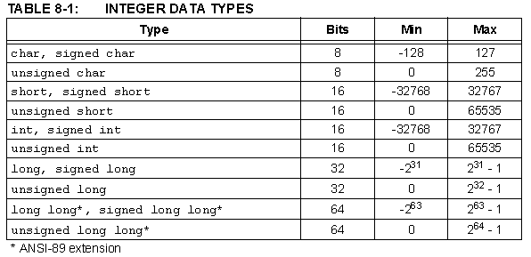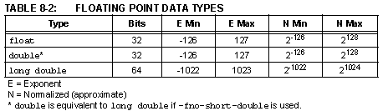Note for our **processor there is no difference between float and double**

void __attribute__((__interrupt__,__auto_psv__)) _StackError(void);

pl = pl-5; // now pl points to 0x4312 **not** 0x 4317

* You **can not** use an assignment statement for a string:

Floating Point Representation

* Exponent value always subtract 0x7F

